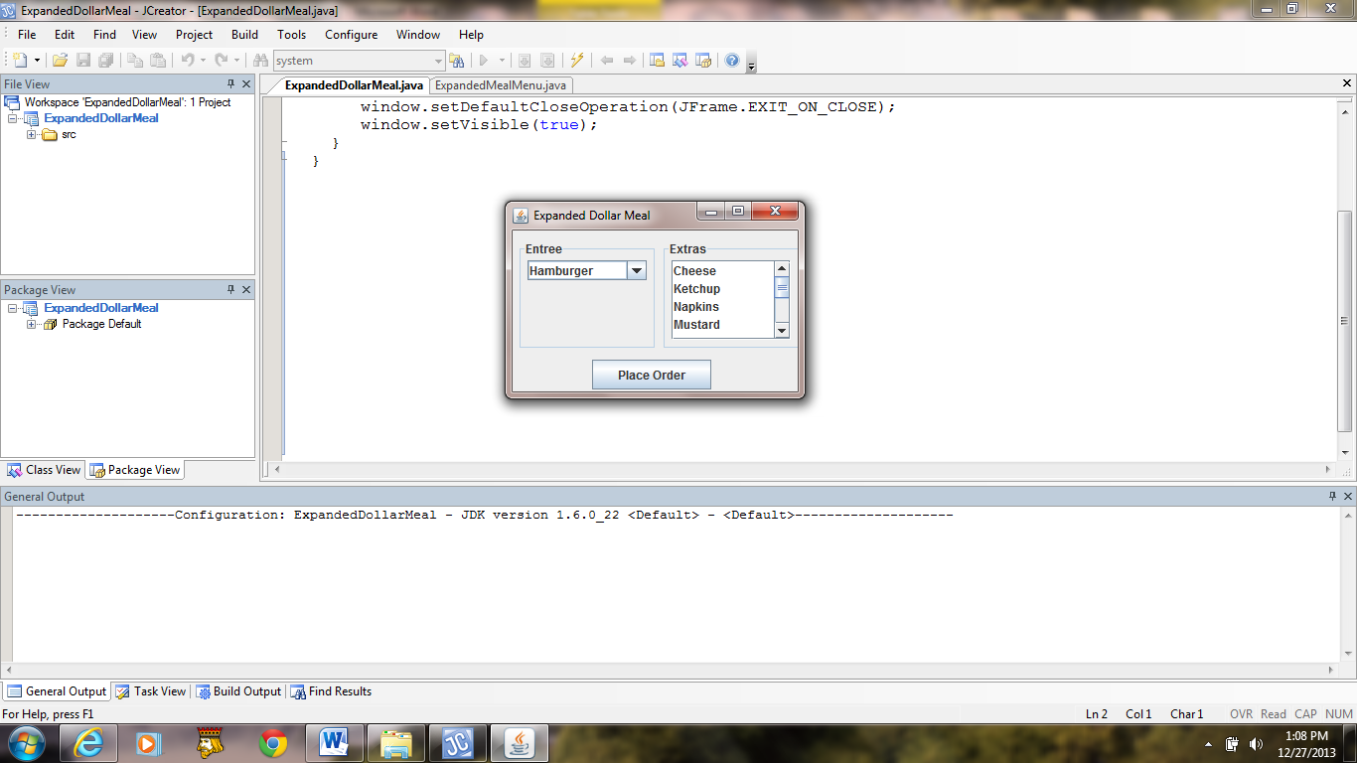 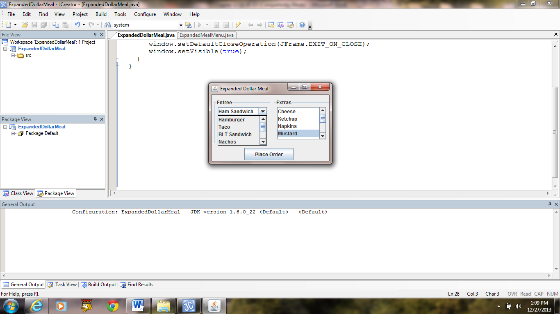

a) b)

Entree Number -1: Ham Sandwich, Mustard

**Figure 12.10 The GUI of the application DollarMeal with an editable combo box.**